Final Project & Extra Credit
CMPENG 331
Mohammad Abu Shariha
Mma7020@psu.edu

Abstract
In this project we look at how an MIPS CPU works, focusing on its five main parts: Instruction Fetch (IF), Instruction Decode (ID), Execution (EXE), Memory (MEM), and Writeback (WB). It explains what each part does and how they work together. It also discusses improvements for handling different kinds of instructions and avoiding slowdowns. Overall, this paper provides a clear understanding of how a MIPS CPU operates, including its main parts, handling different instructions, and avoiding slowdowns.
Introduction:
Pipelining is a fundamental technique used in modern processors to improve performance by allowing multiple instructions to be processed simultaneously across different stages. Instead of completing one instruction at a time, a pipelined CPU divides instruction execution into distinct phases and overlaps their operations, significantly increasing overall instruction throughput.
This project implements a five-stage pipelined MIPS CPU consisting of the following stages: Instruction Fetch (IF), Instruction Decode (ID), Execution (EXE), Memory Access (MEM), and Write Back (WB). Pipeline registers are utilized between these stages to store intermediate data and control signals, enabling a correct and efficient flow of instructions through the processor.
To ensure accurate execution, the design includes mechanisms for handling data hazards through forwarding and pipeline stalls, as well as control hazards using a delayed branch strategy. Branch decisions and jump targets are calculated in the Instruction Decode stage to minimize performance penalties. The processor supports a wide range of MIPS instructions, including arithmetic, logical, memory access, branching, and subroutine operations. The design was implemented in Verilog and verified through simulation and FPGA synthesis.

Stage 1: Instruction Fetch (IF)

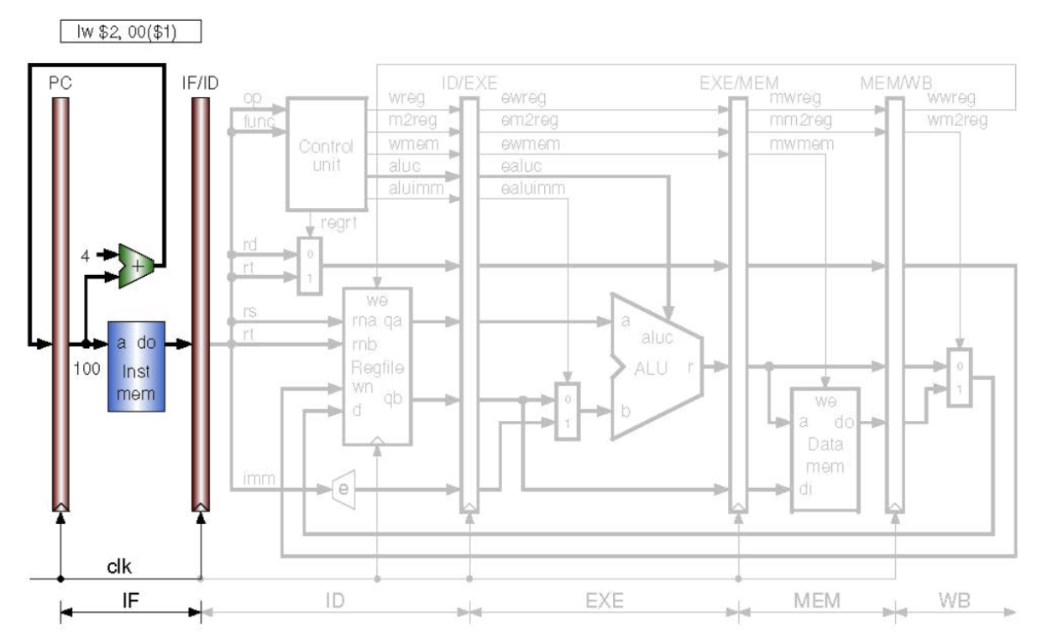
The initial stage of the pipeline relies on a clock signal generated by the top-level testbench to drive the Program Counter (PC). This stage activates four primary modules:
- Program Counter: Initiating at a value of 100, this module updates to the next address only upon the rising edge of the clock signal.
- PC Adder: This component increments the Program Counter by a value of 4 during every cycle to calculate the next instruction address.
- Instruction Memory: This module houses the CPU instructions, specifically occupying memory slots 25 through 29.
- IF/ID Pipeline: Serving as the buffer between the Instruction Fetch and Instruction Decode stages, this register latches the output from instruction memory on the positive clock edge, a behavior consistent across all five pipeline registers.

Stage 2: Instruction Decode (ID)

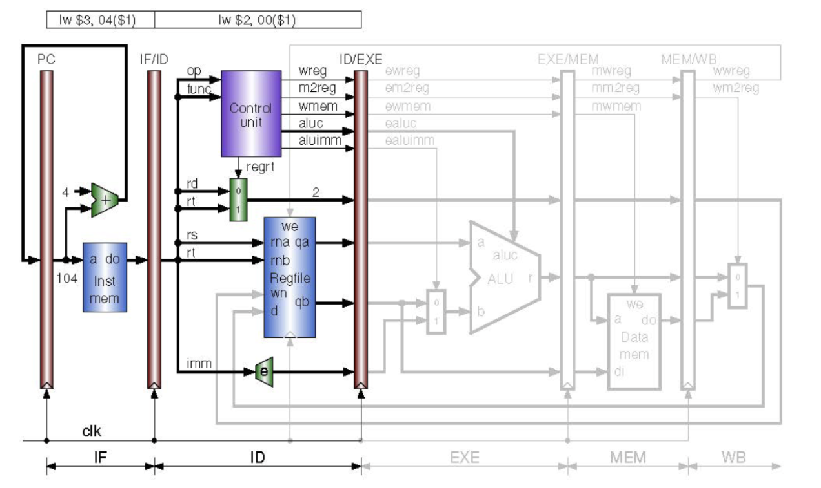

The second stage of the pipeline focuses on decoding the instruction received from the previous stage. This process occurs in parallel with the instruction fetch stage, which retrieves the subsequent instruction assuming no stalls occur. Upon entering this stage, the instruction is decomposed into its specific components (rs, rt, rd, op, func, and imm), with wire sizes configured to match the requirements of each segment.
The stage is composed of the following key modules:
- Immediate Extender: This module processes the immediate portion (imm), which comprises the last 16 bits of the instruction. It extends these bits into a 32-bit number using sign extension. This is achieved by replicating the 16th bit (the sign bit) into the most significant positions; if the bit is 1, the upper bits are set to 1, and if it is 0, they are set to 0.
- Register File: The register file accesses the register addresses for rs and rt as specified by the opcode. It outputs the corresponding 32-bit values, referred to as qa for the rs address and qb for the rt address.
- Regrt Multiplexer: The regrtMux determines the destination register based on the regrt control signal. If the signal is active (1), rt is passed through; if it is inactive (0), the alternative register is passed through.
- Control Unit: Acting as the processing logic of the CPU, the control unit determines the necessary output signals for each instruction type. While previous implementations included load word instructions, this project focuses on R-type instructions such as add, or, and, xor, and sub. The logic is implemented using case statements to set outputs based on the opcode and function.
- ID/EXE Pipeline: The stage concludes with the ID/EXE pipeline register. This component separates the instruction decode stage from the execution stage, updating its output values only on the positive edge of the clock signal.

Stage 3: Execution (EXE)
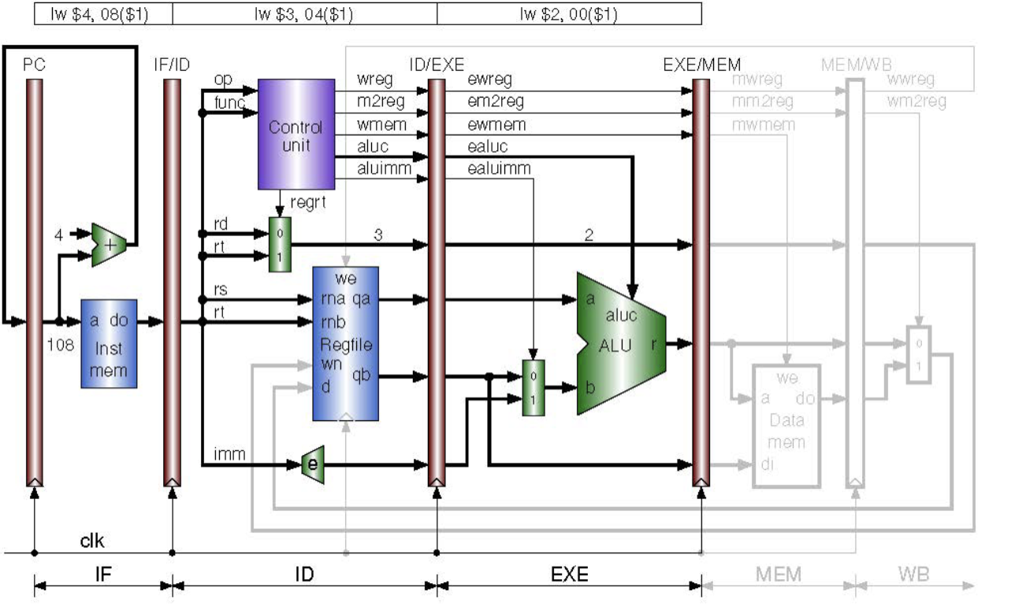
The execution stage commences by receiving data from the ID/EXE pipeline register. Upon entry, the data encounters a multiplexer positioned immediately before the Arithmetic Logic Unit (ALU). This multiplexer determines the second operand for the calculation by selecting between the register value qb and the immediate extended value, a decision controlled by the ealuimm signal.
Once the inputs are selected, the ALU performs the specific arithmetic operation dictated by the aluc signal provided by the control unit. This process generates a result, designated as r, which is output by the ALU. The stage concludes with the EXE/MEM pipeline register, which captures and passes the updated values to the next stage on the positive edge of the clock signal.
Stage 4: Memory (MEM)
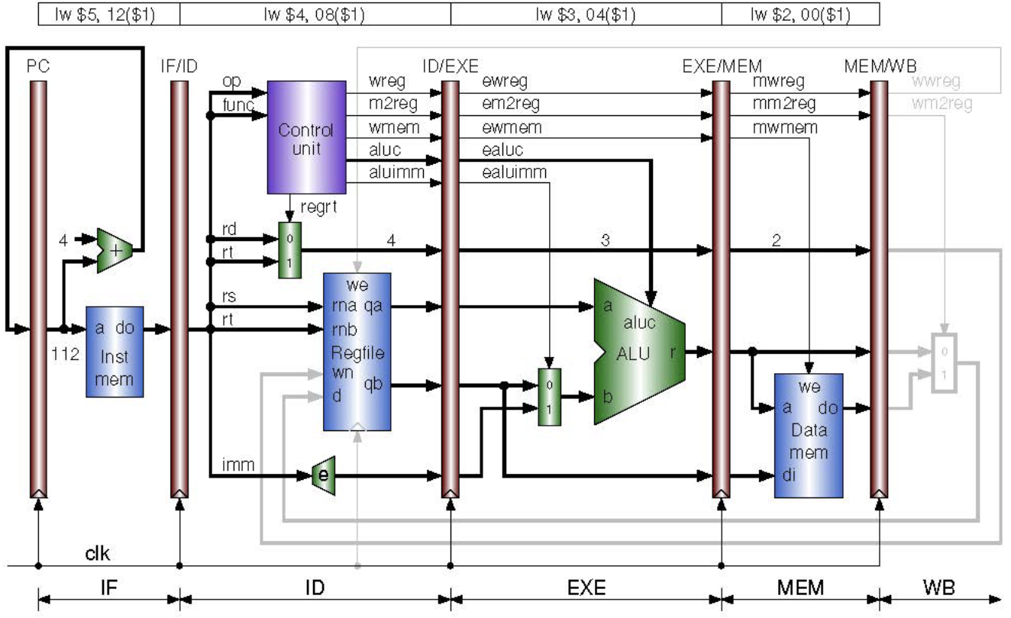
The fourth stage begins with the EXE/MEM pipeline, which transmits values on the positive clock edge. The core function of this stage is performed by the data memory module, which handles memory storage and facilitates register writing as necessary; specifically, it stores the results produced by the ALU if the instruction requires it. The stage concludes with the MEM/WB pipeline, which updates the output signals on the positive edge of the clock.

Stage 5: Writeback (WB)
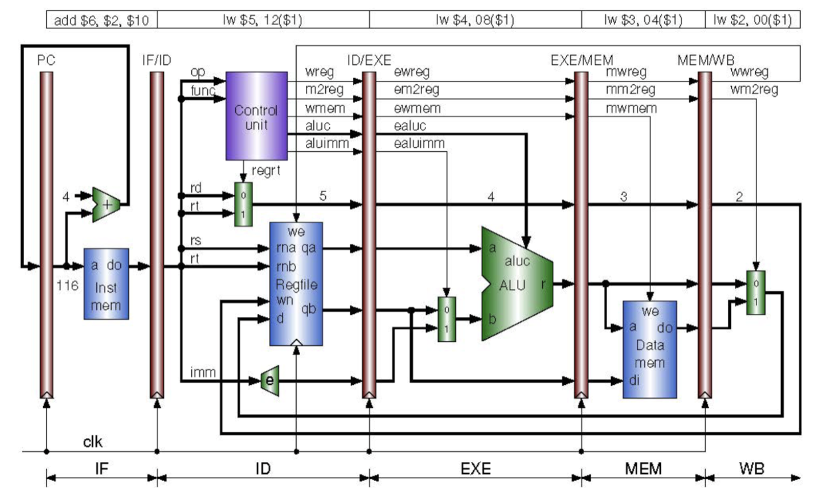
The final phase of the pipeline is the writeback stage, which consists of two primary modules: the MEM/WB pipeline and the writeback multiplexer. The MEM/WB pipeline transmits values from the fourth stage on the positive edge of the clock, while the writeback multiplexer determines which specific value is routed back to the register file in the second stage.
The multiplexer selection is governed by the wm2reg signal. If wm2reg is set to 0, the delayed ALU result, referred to as wr, is passed through to the register file. If wm2reg is set to 1, the delayed output from the data memory module, referred to as wdo, is selected. Finally, the wwreg signal indicates whether a register write is required; notably, this write operation is executed on the negative edge of the clock.

Forwarding:
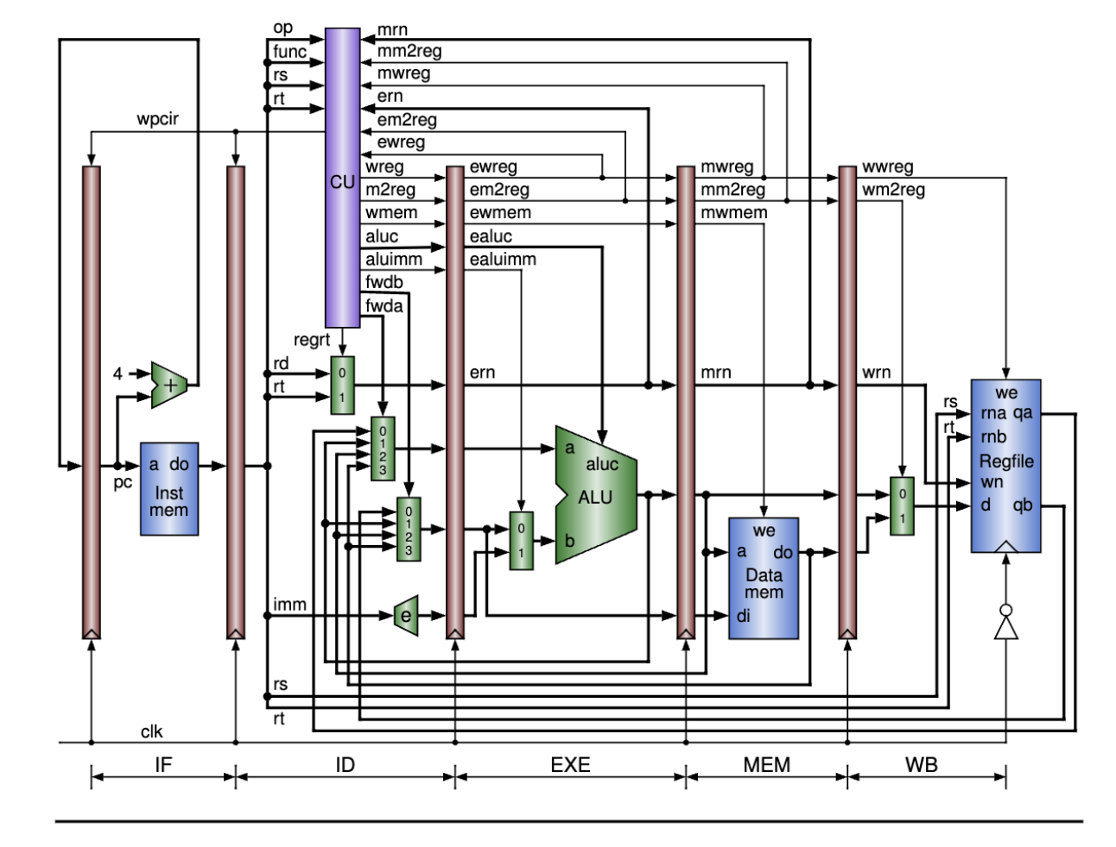
To finalize the project, additional modules and modifications were introduced across the pipeline stages to enhance the CPU with proper hazard detection and data forwarding capabilities. Additionally, stall logic was implemented to fulfill extra credit requirements, separate from the core project objectives.
Two specific modules, ForwardMuxA and ForwardMuxB, were integrated into the CPU architecture. These multiplexers serve to manage the inputs qa and qb, respectively. They function by determining whether the system requires ALU forwarding, memory forwarding, data memory forwarding, or no forwarding at all.
To govern these operations, a hazard detection segment was incorporated into the Control Unit. This logic utilizes eight new inputs and a set of conditional statements to identify potential hazards. Based on this analysis, the unit outputs the appropriate control signals, fwda and fwdb. These signals are transmitted to the forwarding multiplexers, which then select the correct values to feed back into the datapath. This implementation fulfills all essential aspects of the final project as outlined in the rubric.

Implementing Extra Credit:
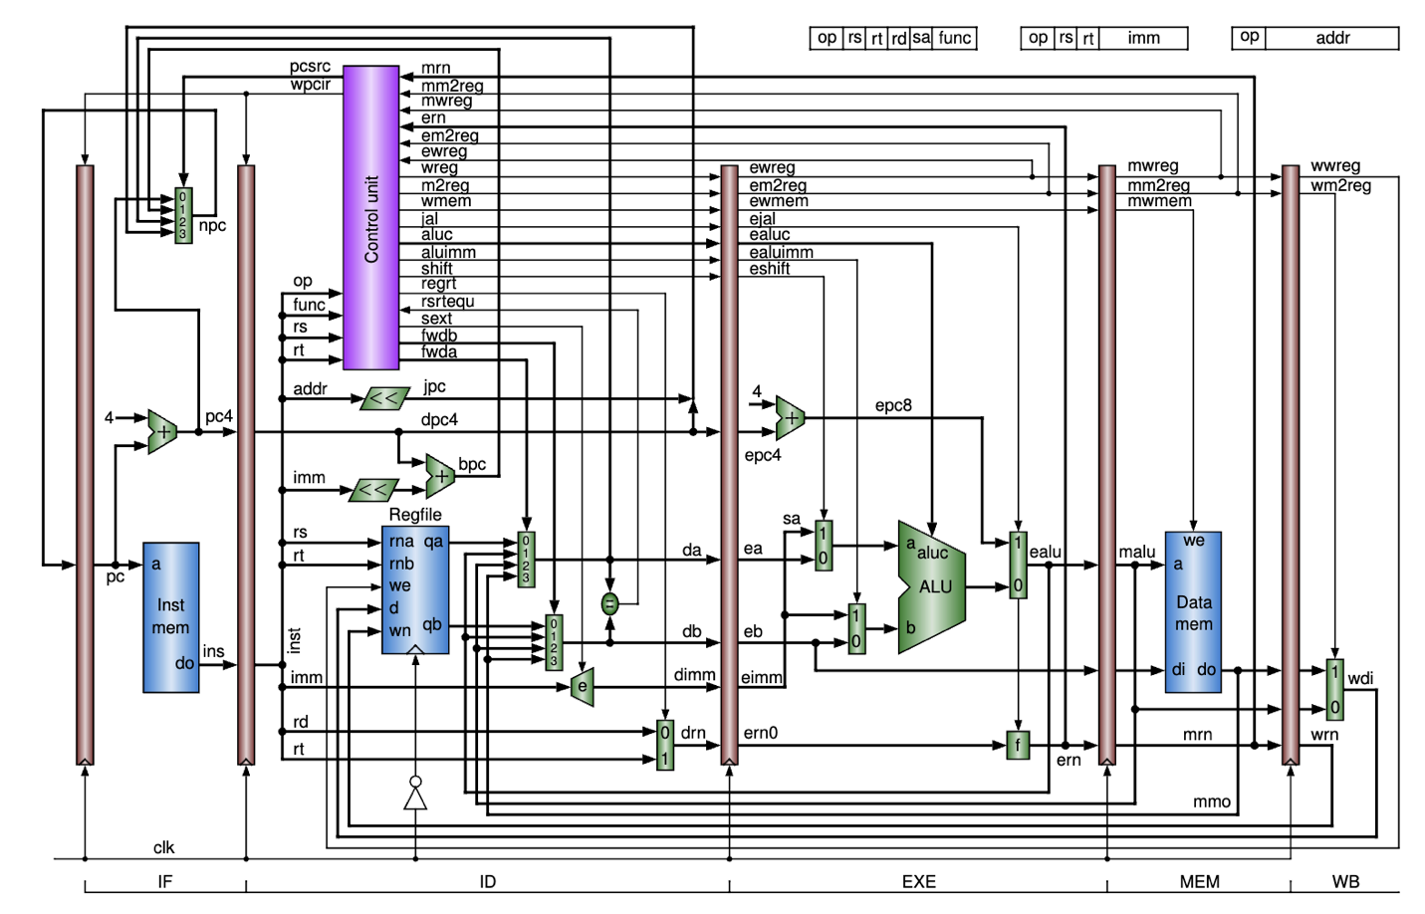
For the extra credit component, the MIPS CPU was expanded to support a wider range of operations, including branching, jumping, load word, store word, load upper immediate, jump and link, and the majority of R-type instructions.
- Instruction Fetch Stage: A Program Counter Multiplexer (PCMux) was introduced to select the next program counter value based on the specific instruction type being executed.
- Instruction Decode Stage: This stage was modified to include left-shift modules for processing jump and branch instructions. Additionally, an immediate extender with sign extension capabilities and a branch equality checker were integrated to handle the new logic.
- Execution Stage: New modules were implemented in this stage to manage program counter updates for jump and link instructions, as well as to handle multiplexer selection for shifting operations.
- Memory and Writeback Stages: No modifications were made to the memory or writeback stages for this implementation.

Images:

Floorplanning:
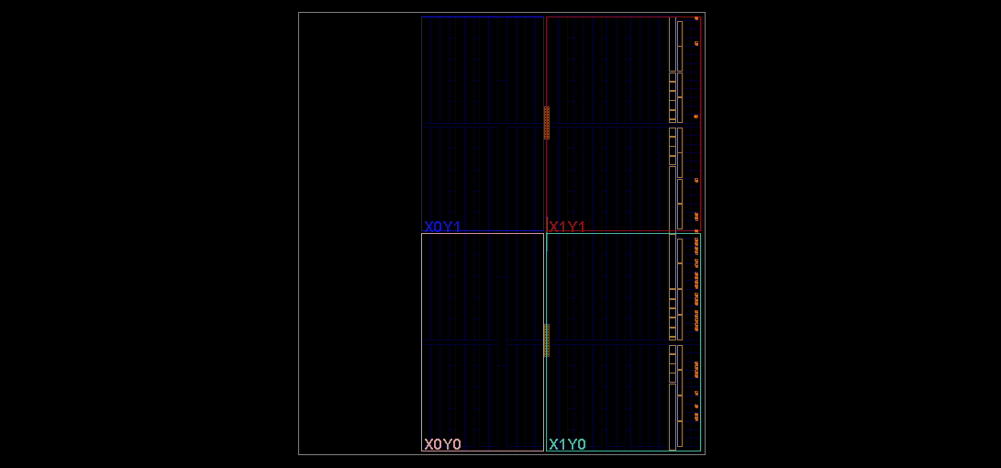
I/O Planning:
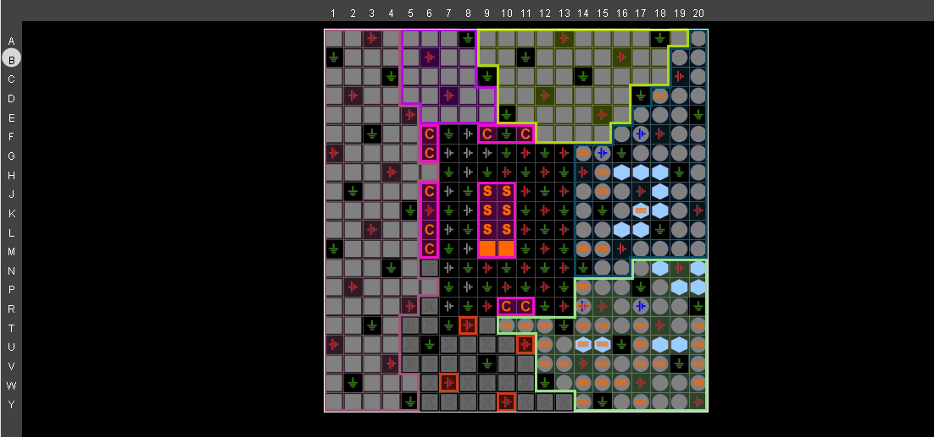
Design schematics:
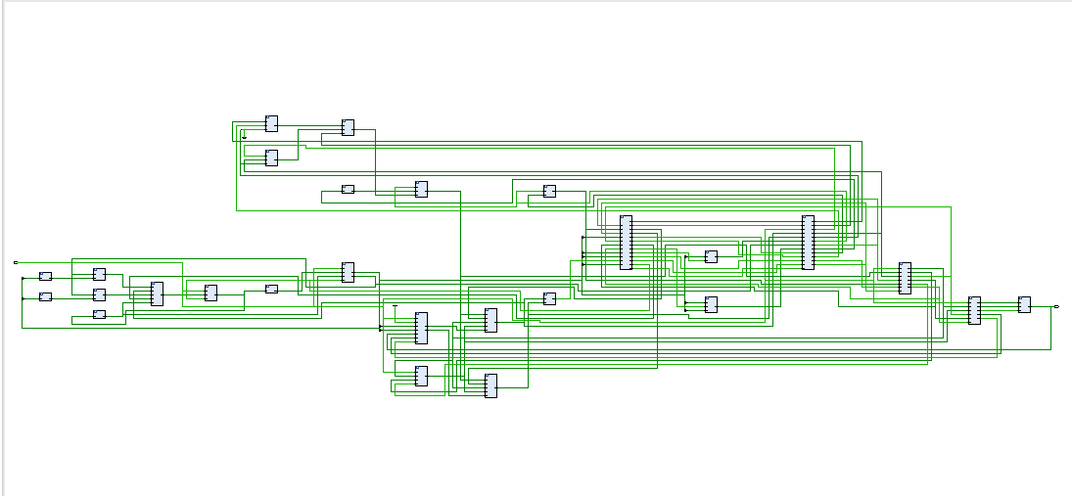
Synthesized design:
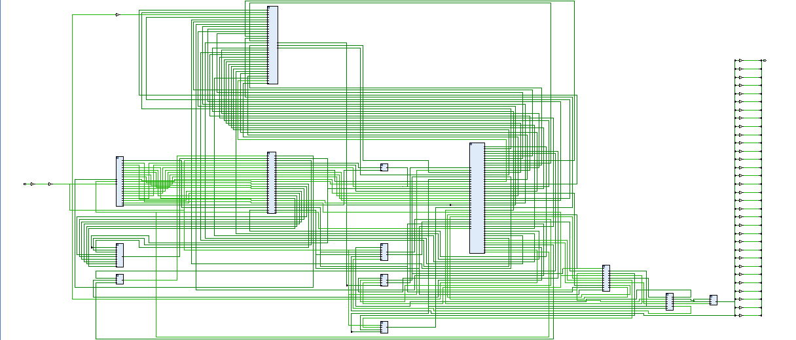
Waveform:
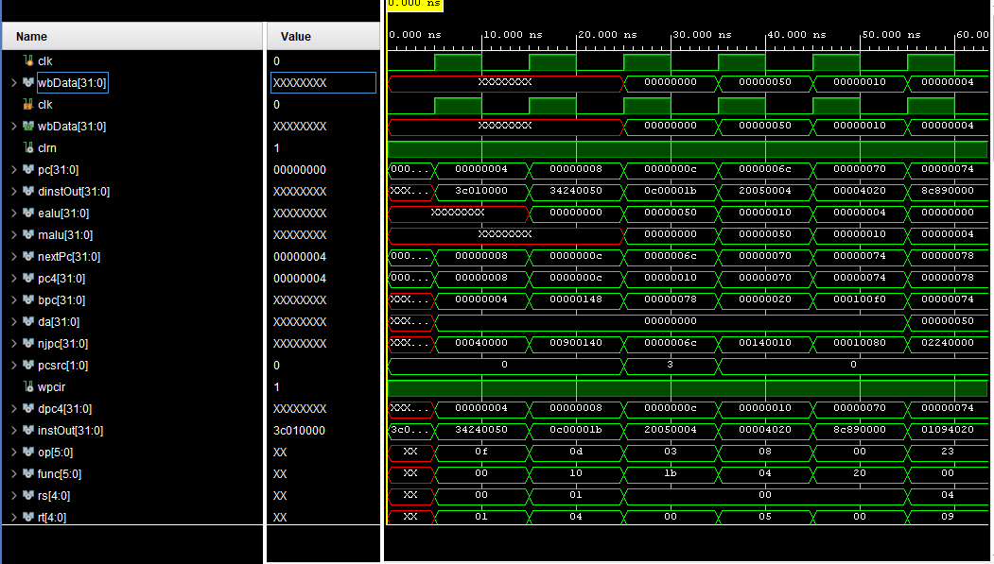
Bitstream Generation:
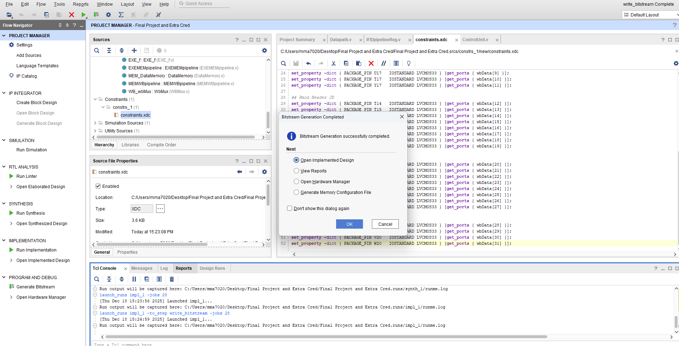
Code:
`timescale 1ns / 1ps

module Datapath(
input clk,
output wire [31:0] wbData
);
wire clrn;
assign clrn = 1'b1;

wire [31:0] pc;
wire [31:0] dinstOut;
wire [31:0] ealu;
wire [31:0] malu;

wire [31:0] nextPc;
wire [31:0] pc4;
wire [31:0] bpc;
wire [31:0] da;
wire [31:0] njpc;
wire [1:0] pcsrc;
wire wpcir;
wire [31:0] dpc4;
wire [31:0] instOut;
wire [5:0] op;
wire [5:0] func;
wire [4:0] rs;
wire [4:0] rt;
wire [4:0] rd;
wire [15:0] imm;
wire [25:0] addr;
wire [31:0] qa;
wire [31:0] qb;
wire [31:0] immOut;
wire [25:0] jpc;
wire wwreg;
wire [4:0] wrn;
wire [31:0] mdo;
wire [31:0] db;
wire sext;
wire [31:0] dimm32;
wire [31:0] eimm32;
wire regrt;
wire [4:0] drn;
wire [4:0] mrn;
wire mm2reg;
wire mwreg;
wire [4:0] ern;
wire em2reg;
wire ewreg;
wire wreg;
wire m2reg;
wire wmem;
wire jal;
wire [3:0] aluc;
wire aluimm;
wire shift;
wire rsrtequ;
wire [1:0] fwda;
wire [1:0] fwdb;
wire ewmem;
wire ejal;
wire [3:0] ealuc;
wire ealuimm;
wire eshift;
wire [31:0] sa;
wire [31:0] ea;
wire [31:0] eb;
wire [31:0] epc4;
wire [31:0] epc8;
wire [31:0] a;
wire [31:0] b;
wire [31:0] r;
wire [4:0] ern0;
wire mwmem;
wire [31:0] mb;
wire wm2reg;
wire [31:0] walu;
wire [31:0] wdo;

ProgramCounter IF_ProgramCounter(.pc(pc), .clk(clk), .nextPc(nextPc), .wpcir(wpcir));
pcAdder IF_PCAdder(.pc(pc), .pc4(pc4));
IF_ProgramCounterMux IF_PCMux(.pc4(pc4), .bpc(bpc), .da(da), .njpc(njpc), .pcsrc(pcsrc), .nextPc(nextPc));
InstructionMemory IF_InstructionMemory(.pc(pc), .instOut(instOut));
IFIDpipelineReg IFIDpipeline(.wpcir(wpcir), .pc4(pc4), .instOut(instOut), .clk(clk), .dinstOut(dinstOut), .dpc4(dpc4));
ID_addrLS ID_addrLS(.addr(addr), .jpc(jpc));
ID_immLS ID_immLS(.imm(imm), .immOut(immOut));
ID_BranchProgramCounter ID_BPC(.dpc4(dpc4), .immOut(immOut), .bpc(bpc));
RegisterFile ID_RegFile(.rs(rs), .rt(rt), .wwreg(wwreg), .clrn(clrn), .clk(clk), .wbData(wbData), .wrn(wrn), .qa(qa), .qb(qb));
Fwd_FwdMuxA ID_FwdMuxA(.qa(qa), .malu(malu), .ealu(ealu), .mdo(mdo), .fwda(fwda), .da(da));
Fwd_FwdMuxB ID_FwdMuxB(.qb(qb), .malu(malu), .ealu(ealu), .mdo(mdo), .fwdb(fwdb), .db(db));
ImmediateExtender ID_IE(.imm(imm), .dimm32(dimm32), .sext(sext));
RegrtMultiplexer ID_RegrtMux(.rd(rd), .rt(rt), .regrt(regrt), .drn(drn));
ID_rsrtequCheck ID_rsrtequCheck(.da(da), .db(db), .rsrtequ(rsrtequ));
ID_JumpPCconcatination ID_JPCconcat(.jpc(jpc), .dpc4(dpc4), .njpc(njpc));
ControlUnit ID_ControlUnit(.op(op), .rs(rs), .rt(rt), .func(func), .pcsrc(pcsrc), .wpcir(wpcir),
.mrn(mrn), .mm2reg(mm2reg), .mwreg(mwreg), .ern(ern), .em2reg(em2reg), .ewreg(ewreg), .wreg(wreg),
.m2reg(m2reg), .wmem(wmem), .jal(jal), .aluc(aluc), .aluimm(aluimm), .shift(shift), .regrt(regrt),
.rsrtequ(rsrtequ), .sext(sext), .fwda(fwda), .fwdb(fwdb));
IDEXEpipeline IDEXEpipeline(.wreg(wreg), .m2reg(m2reg), .wmem(wmem), .jal(jal), .aluc(aluc), .aluimm(aluimm),
.shift(shift), .dpc4(dpc4), .da(da), .db(db), .dimm32(dimm32), .drn(drn), .clk(clk), .ern0(ern0), .eimm32(eimm32),
.eb(eb), .ea(ea), .epc4(epc4), .eshift(eshift), .ealuimm(ealuimm), .ealuc(ealuc), .ejal(ejal), .ewmem(ewmem),
.em2reg(em2reg), .ewreg(ewreg));
EXE_ProgramCounter EXE_ProgramCounter(.epc4(epc4), .epc8(epc8));
EXE_ALUMux2 EXE_ALUMuxA(.sa(sa), .ea(ea), .eshift(eshift), .a(a));
ALUMux EXE_ALUMuxB(.eimm32(eimm32), .eb(eb), .ealuimm(ealuimm), .b(b));
ALU EXE_ALU(.a(a), .b(b), .r(r), .ealuc(ealuc));
EXE_ALUoutMux EXE_ealuMux(.epc8(epc8), .r(r), .ejal(ejal), .ealu(ealu));
EXE_f EXE_f(.ern0(ern0), .ern(ern), .ejal(ejal));
EXEMEMpipeline EXEMEMpipeline(.ewreg(ewreg), .em2reg(em2reg), .ewmem(ewmem), .ealu(ealu), .eb(eb), .ern(ern),
.clk(clk), .mrn(mrn), .mb(mb), .malu(malu), .mwmem(mwmem), .mm2reg(mm2reg), .mwreg(mwreg));
DataMemory MEM_DataMemory(.malu(malu), .mb(mb), .mwmem(mwmem), .mdo(mdo), .clk(clk));
MEMWBpipeline MEMWBpipeline(.mwreg(mwreg), .mm2reg(mm2reg), .mdo(mdo), .malu(malu), .mrn(mrn), .clk(clk),
.wrn(wrn), .walu(walu), .wdo(wdo), .wm2reg(wm2reg), .wwreg(wwreg));
WbMux WB_wbMux(.wdo(wdo), .walu(walu), .wbData(wbData), .wm2reg(wm2reg));

assign op = dinstOut[31:26];
assign func = dinstOut[5:0];
assign rs = dinstOut[25:21];
assign rt = dinstOut[20:16];
assign rd = dinstOut[15:11];
assign imm = dinstOut[15:0];
assign sa = {21'b0,eimm32[10:6],6'b0};
assign addr = dinstOut[25:0];

endmodule

`timescale 1ns / 1ps

module ProgramCounter(
input clk,
input [31:0] nextPc,

input wpcir,

output reg [31:0] pc

);

initial
begin
pc = 32'd0;
end

always @(posedge clk)
begin
if (wpcir == 1)
pc = nextPc;
end

endmodule

`timescale 1ns / 1ps

module pcAdder(
input [31:0] pc,
output reg [31:0] pc4
);

always @(*) begin
pc4 <= pc + 32'b00000000000000000000000000000100;
end

endmodule

`timescale 1ns / 1ps

module IF_ProgramCounterMux(
input [1:0] pcsrc,
input [31:0] pc4,
input [31:0] bpc,
input [31:0] njpc,
input [31:0] da,
output reg [31:0] nextPc
);

always @ (*)
begin
case(pcsrc)
2'b00: nextPc = pc4;
2'b01: nextPc = bpc;
2'b10: nextPc = da;
2'b11: nextPc = njpc;
endcase
end
endmodule

`timescale 1ns / 1ps

module InstructionMemory( // instruction memory, rom
input [31:0] pc, // rom address
output reg [31:0] instOut // rom content = rom[a]
);
wire [31:0] rom [0:63]; // rom cells: 64 words * 32 bits
// rom[word_addr] = instruction // (pc) label instruction
assign rom[6'h00] = 32'h3c010000; // (00) main: lui $1, 0
assign rom[6'h01] = 32'h34240050; // (04) ori $4, $1, 80
assign rom[6'h02] = 32'h0c00001b; // (08) call: jal sum
assign rom[6'h03] = 32'h20050004; // (0c) dslot1: addi $5, $0, 4
assign rom[6'h04] = 32'hac820000; // (10) return: sw $2, 0($4)
assign rom[6'h05] = 32'h8c890000; // (14) lw $9, 0($4)
assign rom[6'h06] = 32'h01244022; // (18) sub $8, $9, $4
assign rom[6'h07] = 32'h20050003; // (1c) addi $5, $0, 3
assign rom[6'h08] = 32'h20a5ffff; // (20) loop2: addi $5, $5, -1
assign rom[6'h09] = 32'h34a8ffff; // (24) ori $8, $5, 0xffff
assign rom[6'h0a] = 32'h39085555; // (28) xori $8, $8, 0x5555
assign rom[6'h0b] = 32'h2009ffff; // (2c) addi $9, $0, -1
assign rom[6'h0c] = 32'h312affff; // (30) andi $10,$9,0xffff
assign rom[6'h0d] = 32'h01493025; // (34) or $6, $10, $9
assign rom[6'h0e] = 32'h01494026; // (38) xor $8, $10, $9
assign rom[6'h0f] = 32'h01463824; // (3c) and $7, $10, $6
assign rom[6'h10] = 32'h10a00003; // (40) beq $5, $0, shift
assign rom[6'h11] = 32'h00000000; // (44) dslot2: nop
assign rom[6'h12] = 32'h08000008; // (48) j loop2
assign rom[6'h13] = 32'h00000000; // (4c) dslot3: nop
assign rom[6'h14] = 32'h2005ffff; // (50) shift: addi $5, $0, -1
assign rom[6'h15] = 32'h000543c0; // (54) sll $8, $5, 15
assign rom[6'h16] = 32'h00084400; // (58) sll $8, $8, 16
assign rom[6'h17] = 32'h00084403; // (5c) sra $8, $8, 16
assign rom[6'h18] = 32'h000843c2; // (60) srl $8, $8, 15
assign rom[6'h19] = 32'h08000019; // (64) finish: j finish
assign rom[6'h1a] = 32'h00000000; // (68) dslot4: nop
assign rom[6'h1b] = 32'h00004020; // (6c) sum: add $8, $0, $0
assign rom[6'h1c] = 32'h8c890000; // (70) loop: lw $9, 0($4)
assign rom[6'h1d] = 32'h01094020; // (74) stall: add $8, $8, $9
assign rom[6'h1e] = 32'h20a5ffff; // (78) addi $5, $5, -1
assign rom[6'h1f] = 32'h14a0fffc; // (7c) bne $5, $0, loop
assign rom[6'h20] = 32'h20840004; // (80) dslot5: addi $4, $4, 4
assign rom[6'h21] = 32'h03e00008; // (84) jr $31
assign rom[6'h22] = 32'h00081000; // (88) dslot6: sll $2, $8, 0
always @(*)
begin
instOut = rom[pc[7:2]]; // use 6-bit word address to read rom
end
endmodule

`timescale 1ns / 1ps

module IFIDpipelineReg(
input clk,
input [31:0] instOut,
input [31:0] pc4,
input wpcir,
output reg [31:0] dinstOut,
output reg [31:0] dpc4
);

always @ (posedge clk)
begin
if (wpcir == 1) begin
dinstOut <= instOut;
dpc4 <= pc4;
end
end

endmodule

`timescale 1ns / 1ps

module ID_addrLS(
input [25:0] addr,
output reg [25:0] jpc
);
always @ (*)
begin
jpc = addr << 2;
end
endmodule

`timescale 1ns / 1ps

module ID_immLS(
input [15:0] imm,
output reg [31:0] immOut
);

always @ (*)
begin
immOut = {{16{imm[15]}}, imm} << 2;
end
endmodule

`timescale 1ns / 1ps

module ID_BranchProgramCounter(
input [31:0] dpc4,
input [31:0] immOut,
output reg [31:0] bpc
);

always @ (*)
begin
bpc <= dpc4 + immOut;
end

endmodule

`timescale 1ns / 1ps

module RegisterFile(
// Inputs
input [4:0] rs, // Input for the source register (rs)
input [4:0] rt, // Input for the target register (rt)

//Lab 5 Inputs
input [4:0] wrn,
input [31:0] wbData,
input wwreg,
input clk, clrn,

// Outputs
output reg [31:0] qa, // Output for the value stored in the source register
output reg [31:0] qb // Output for the value stored in the target register

);

reg [31:0] register [0:31]; // 32x32 array for registers (register file)

// Initialize all registers to 0
integer r;
initial begin
for (r = 0; r <= 31; r = r + 1) begin
register[r] = 0; // Initialize each register to 0.
end
end

always @ (*) // Always block to update qa and qb based on the input rs and rt values.
begin
qa = register[rs]; // Output qa is the value stored in the source register (rs).
qb = register[rt]; // Output qb is the value stored in the target register (rt).
end

always @ (negedge clk)
begin
if (wwreg == 1)
register[wrn] = wbData;
end

endmodule

`timescale 1ns / 1ps

module Fwd_FwdMuxA(
input [1:0] fwda,
input [31:0] qa,
input [31:0] ealu,
input [31:0] malu,
input [31:0] mdo,
output reg [31:0] da
);

always @ (*) begin
case(fwda)
2'b00: da <= qa;
2'b01: da <= ealu;
2'b10: da <= malu;
2'b11: da <= mdo;
endcase
end
endmodule

`timescale 1ns / 1ps

module Fwd_FwdMuxB(
input [1:0] fwdb,
input [31:0] qb,
input [31:0] ealu,
input [31:0] malu,
input [31:0] mdo,
output reg [31:0] db
);

always @ (*) begin
case(fwdb)
2'b00: db <= qb;
2'b01: db <= ealu;
2'b10: db <= malu;
2'b11: db <= mdo;
endcase
end

endmodule

`timescale 1ns / 1ps

module ImmediateExtender( //immediate extender module.
input [15:0] imm,
input sext,
output reg [31:0] dimm32
);

always @ (*) //always block to update the value of imm32.
begin
if (sext == 1)
dimm32 = {{16{imm[15]}}, imm}; //sets imm32 to be equal to imm. the last bit is concatinated to the other 16 bits based on if the sign bit is a zero or one.
else
dimm32 <= {16'b0, imm};
end
endmodule

`timescale 1ns / 1ps

module RegrtMultiplexer(
// Inputs
input [4:0] rt, // Input register value rt
input [4:0] rd, // Input register value rd
input regrt, // Control signal to select the output (0 for rd, 1 for rt)

// Output
output reg [4:0] drn // Output register value (selected based on the control signal)
);

always @(*)
begin
if (regrt == 0)
drn = rd; // If regrt is 0, select rd as the output.
else
drn = rt; // If regrt is 1, select rt as the output.
end

endmodule

`timescale 1ns / 1ps

module ID_rsrtequCheck(
input [31:0] da,
input [31:0] db,
output reg rsrtequ
);

always @ (*)
begin
if (da == db)
rsrtequ <= 1;
else
rsrtequ <= 0;
end
endmodule

`timescale 1ns / 1ps

module ID_JumpPCconcatination(
input [25:0] jpc,
input [31:0] dpc4,
output reg [31:0] njpc
);

always @ (*)
begin
njpc <= {{dpc4[31:26]}, jpc};
end
endmodule

`timescale 1ns / 1ps

module ControlUnit(
//inputs
input [5:0] op, func,

//final project inputs
input [4:0] rs, rt, mrn, ern,
input mm2reg, mwreg, em2reg, ewreg,

//Extra Credit Input
input rsrtequ,

//outputs
output reg wreg, m2reg, wmem, aluimm, regrt,
output reg [3:0] aluc,

//final project outputs
output reg [1:0] fwda, fwdb,
output reg wpcir,

//Extra Credit Outputs
output reg sext, shift, jal,
output reg [1:0] pcsrc
);

reg regUsage = 1'b1;

initial begin
wreg <= 0;
m2reg <= 0;
wmem <= 0;
aluimm <= 0;
regrt <= 0;
pcsrc <= 2'b00;
end

// Combined Always Block to prevent Multiple Driver Errors
always @ (*) begin
// 1. DEFAULT VALUES (Prevent Latches)
wreg = 0; m2reg = 0; wmem = 0; aluimm = 0; regrt = 0;
aluc = 4'b0000; sext = 0; shift = 0; jal = 0; pcsrc = 0;
wpcir = 1; fwda = 0; fwdb = 0; // Default: No stall, No forward

// 2. INSTRUCTION DECODE LOGIC
case (op)
6'b000000: // R-type instructions
begin
case (func)
6'b100000: begin // ADD
aluc = 4'b0010; wreg = 1; m2reg = 0; wmem = 0; aluimm = 0; regrt = 0; sext = 1'bx; jal = 0; shift = 0; pcsrc = 2'b00;
end
6'b100010: begin // SUB
aluc = 4'b0110; wreg = 1; m2reg = 0; wmem = 0; aluimm = 0; regrt = 0; sext = 1'bx; jal = 0; shift = 0; pcsrc = 2'b00;
end
6'b100100: begin // AND
aluc = 4'b0000; wreg = 1; m2reg = 0; wmem = 0; aluimm = 0; regrt = 0; sext = 1'bx; jal = 0; shift = 0; pcsrc = 2'b00;
end
6'b100101: begin // OR
aluc = 4'b0001; wreg = 1; m2reg = 0; wmem = 0; aluimm = 0; regrt = 0; sext = 1'bx; jal = 0; shift = 0; pcsrc = 2'b00;
end
6'b100110: begin // XOR
aluc = 4'b0011; wreg = 1; m2reg = 0; wmem = 0; aluimm = 0; regrt = 0; sext = 1'bx; jal = 0; shift = 0; pcsrc = 2'b00;
end
6'b000000: begin // sll
aluc = 4'b0111; wreg = 1; m2reg = 0; wmem = 0; aluimm = 0; regrt = 0; sext = 1'bx; jal = 0; shift = 1; pcsrc = 2'b00;
end
6'b000010: begin // srl
aluc = 4'b1110; wreg = 1; m2reg = 0; wmem = 0; aluimm = 0; regrt = 0; sext = 1'bx; jal = 0; shift = 1; pcsrc = 2'b00;
end
6'b000011: begin // sra
aluc = 4'b1001; wreg = 1; m2reg = 0; wmem = 0; aluimm = 0; regrt = 0; sext = 1'bx; jal = 0; shift = 1; pcsrc = 2'b00;
end
6'b001000: begin // jr
aluc = 4'bxxxx; wreg = 0; wmem = 0; aluimm = 1'bx; regrt = 1'bx; sext = 1'bx; jal = 1'bx; shift = 1'bx; pcsrc = 2'b10;
end
endcase
end

6'b001000: // addi
begin
wreg = 1; regrt = 1; jal = 0; m2reg = 0; shift = 0; aluimm = 1; sext = 1; aluc = 4'b0010; wmem = 0; pcsrc = 2'b00;
end
6'b001100: // andi
begin
wreg = 1; regrt = 1; jal = 0; m2reg = 0; shift = 0; aluimm = 1; sext = 0; aluc = 4'b0000; wmem = 0; pcsrc = 2'b00;
end
6'b001101: // ori
begin
wreg = 1; regrt = 1; jal = 0; m2reg = 0; shift = 0; aluimm = 1; sext = 0; aluc = 4'b0001; wmem = 0; pcsrc = 2'b00;
end
6'b001110: // xori
begin
wreg = 1; regrt = 1; jal = 0; m2reg = 0; shift = 0; aluimm = 1; sext = 0; aluc = 4'b0011; wmem = 0; pcsrc = 2'b00;
end
6'b100011: // LW
begin
wreg = 1; m2reg = 1; wmem = 0; aluc = 4'b0010; aluimm = 1; regrt = 1; jal = 0; shift = 0; pcsrc = 2'b00; sext = 1;
end
6'b101011: // SW
begin
wreg = 0; m2reg = 0; wmem = 1; aluc = 4'b0010; aluimm = 1; regrt = 1'bx; jal = 0; shift = 0; pcsrc = 2'b00; sext = 1;
end
6'b000100: // BEQ
begin
wreg = 0; wmem = 0; aluc = 4'b0011; aluimm = 0; regrt = 1'bx; jal = 1'bx; shift = 0; sext = 1;
if (rsrtequ == 1) pcsrc = 2'b01; else pcsrc = 2'b00;
end
6'b000101: // BNE
begin
wreg = 0; wmem = 0; aluc = 4'b0011; aluimm = 0; regrt = 1'bx; jal = 1'bx; shift = 0; sext = 1;
if (rsrtequ == 0) pcsrc = 2'b01; else pcsrc = 2'b00; // FIXED: Branch if NOT equal (0)
end
6'b001111: // lui
begin
wreg = 1; regrt = 1; jal = 0; m2reg = 0; shift = 1'bx; aluimm = 1; sext = 1'bx; aluc = 4'b0100; wmem = 0; pcsrc = 2'b00;
end
6'b000010: // j
begin
wreg = 0; regrt = 1'bx; jal = 1'bx; m2reg = 1'bx; shift = 1'bx; aluimm = 1'bx; sext = 1'bx; aluc = 4'bxxxx; wmem = 0; pcsrc = 2'b11;
end
6'b000011: // jal
begin
wreg = 1; regrt = 1'bx; jal = 1; shift = 1'bx; aluimm = 1'bx; sext = 1'bx; aluc = 4'bxxxx; wmem = 0; pcsrc = 2'b11;
end
endcase

// 3. STALL LOGIC (Overrides decoding if stall condition is met)
// This ensures wreg and wmem are driven by a single block.
if ((ewreg == 1'b1) && (em2reg == 1'b1) && (ern != 5'b0) && (regUsage == 1'b1) && ((ern == rs) || (ern == rt)))
begin
wreg = 1'b0;
wmem = 1'b0;
wpcir = 1'b0; // STALL: Do not update PC
end
else begin
wpcir = 1'b1; // Normal operation
end

// 4. FORWARDING LOGIC
// Forward A
if ((ewreg == 1'b1) && (ern != 5'b0) && (ern == rs) && (em2reg == 1'b0)) begin
fwda = 2'b01;
end
else if ((mwreg == 1'b1) && (mrn != 5'b0) && (mrn == rs) && (mm2reg == 1'b0)) begin
fwda = 2'b10;
end
else if ((mwreg == 1'b1) && (mrn != 5'b0) && (mrn == rs) && (mm2reg == 1'b1)) begin
fwda = 2'b11;
end
else begin
fwda = 2'b00;
end

// Forward B
if ((ewreg == 1'b1) && (ern != 5'b0) && (ern == rt) && (em2reg == 1'b0)) begin
fwdb = 2'b01;
end
else if ((mwreg == 1'b1) && (mrn != 5'b0) && (mrn == rt) && (mm2reg == 1'b0)) begin
fwdb = 2'b10;
end
else if ((mwreg == 1'b1) && (mrn != 5'b0) && (mrn == rt) && (mm2reg == 1'b1)) begin
fwdb = 2'b11;
end
else begin
fwdb = 2'b00;
end
end
endmodule

`timescale 1ns / 1ps

module IDEXEpipeline(
// Inputs
input wreg, // Control signal for writing to the register file
input m2reg, // Control signal for writing to the register file (M2 stage)
input wmem, // Control signal for writing to memory
input [3:0] aluc, // ALU control signal
input aluimm, // ALU immediate value
input [4:0] drn, // Destination register address
input [31:0] da, // Value from source register A
input [31:0] db, // Value from source register B
input [31:0] dimm32, // 32-bit immediate value
input clk, // Clock signal

//EC Input
input [31:0] dpc4,
input shift, jal,

// Outputs
output reg ewreg, // Output for write enable signal
output reg em2reg, // Output for write enable signal (M2 stage)
output reg ewmem, // Output for memory write enable signal
output reg [3:0] ealuc, // Output for ALU control signal
output reg ealuimm, // Output for ALU immediate value
output reg [4:0] ern0, // Output for destination register address
output reg [31:0] ea, // Output for source register A value
output reg [31:0] eb, // Output for source register B value
output reg [31:0] eimm32, // Output for 32-bit immediate value

//EC Output
output reg [31:0] epc4,
output reg ejal, eshift
);

// On the positive edge of the clock, update the output signals with the input values.
always @ (posedge clk)
begin
ewreg = wreg;
em2reg = m2reg;
ewmem = wmem;
ealuc = aluc;
ealuimm = aluimm;
ern0 = drn;
ea = da;
eb = db;
eimm32 = dimm32;
epc4 = dpc4;
ejal = jal;
eshift = shift;
end
endmodule // End of the module

`timescale 1ns / 1ps

module EXE_ProgramCounter(
input [31:0] epc4,
output reg [31:0] epc8
);

always @ (*)
begin
epc8 <= epc4 + 32'b00000000000000000000000000000100;
end
endmodule

`timescale 1ns / 1ps

module EXE_ALUMux2(
input [31:0] sa,
input [31:0] ea,
input eshift,
output reg [31:0] a
);

always @ (*)
begin
case(eshift)
2'b0: a = ea;
2'b1: a = sa;
endcase
end
endmodule

`timescale 1ns / 1ps

module ALUMux(
input [31:0] eb, // Input B data from the ALU
input [31:0] eimm32, // Immediate value from the pipeline
input ealuimm, // Mux control signal
output reg [31:0] b // Output data selected by the Mux
);

always @(*) begin
case(ealuimm)
1'b0: b <= eb;
1'b1: b <= eimm32;
endcase
end

endmodule

`timescale 1ns / 1ps

module ALU(
input [31:0] a, // Input A for the ALU
input [31:0] b, // Input B for the ALU
input [3:0] ealuc, // ALU control signal
output reg [31:0] r // Output of the ALU
);

// ALU operation codes
// 0000 - AND
// 0001 - OR
// 0010 - ADD
// 0110 - SUBTRACT
// 0111 - SET LESS THAN
// 1100 - NOR
// 0011 - XOR

always @ (*)
begin
case(ealuc)
4'b0000: r = a & b; // AND operation
4'b0001: r = a | b; // OR operation
4'b0010: r = a + b; // ADD operation
4'b0110: r = a - b; // SUBTRACT operation
4'b1100: r = ~(a | b); // NOR operation
4'b0011: r = a ^ b; // XOR operation
4'b0111: r = b << a;//sll
4'b1110: r = b >> a; //srl
4'b1001: r = $signed(b) >>> a; //sra
4'b0100: r = b << 16; //lui
endcase
end
endmodule

`timescale 1ns / 1ps

module EXE_ALUoutMux(
input [31:0] epc8,
input [31:0] r,
input ejal,
output reg [31:0] ealu
);

always @ (*)
begin
case(ejal)
1'b0: ealu = r;
1'b1: ealu = epc8;
endcase
end
endmodule

`timescale 1ns / 1ps

module EXE_f(
input [4:0] ern0,
input ejal,
output reg [4:0] ern
);

always @ (*)
begin
case(ejal)
1'b0: ern = ern0;
1'b1: ern = 5'b11111;
endcase
end

endmodule

`timescale 1ns / 1ps

module EXEMEMpipeline(
input ewreg, // Control signal for writing to the register file
input em2reg, // Control signal for writing to the register file (Memory stage)
input ewmem, // Control signal for writing to memory
input [4:0] ern, // Destination register address
input [31:0] ealu, // Result from the ALU
input [31:0] eb, // Value from source register B
input clk, // Clock signal

output reg mwreg, // Output for write enable signal
output reg mm2reg, // Output for write enable signal (M2 stage)
output reg mwmem, // Output for memory write enable signal
output reg [4:0] mrn, // Output for destination register address
output reg [31:0] malu, // Output for result from the ALU
output reg [31:0] mb // Output for value from source register B
);

always @ (posedge clk)
begin
mwreg = ewreg;
mm2reg = em2reg;
mwmem = ewmem;
mrn = ern;
malu = ealu;
mb = eb;
end

endmodule

`timescale 1ns / 1ps

module DataMemory( // data memory, ram
input clk, // clock
input [31:0] malu, // ram address (addr)
input [31:0] mb, // data in (to memory) (datain)
input mwmem, // write enable (we)
output [31:0] mdo // data out (from memory) (dataout)
);
reg [31:0] ram [0:31]; // ram cells: 32 words * 32 bits
assign mdo = ram[malu[6:2]]; // use 5-bit word address
always @ (posedge clk) begin
if (mwmem) ram[malu[6:2]] = mb; // write ram
end
integer i;
initial begin // ram initialization
for (i = 0; i < 32; i = i + 1)
ram[i] = 0;
// ram[word_addr] = data // (byte_addr) item in data array
ram[5'h14] = 32'h000000a3; // (50) data[0] 0 + a3 = a3
ram[5'h15] = 32'h00000027; // (54) data[1] a3 + 27 = ca
ram[5'h16] = 32'h00000079; // (58) data[2] ca + 79 = 143
ram[5'h17] = 32'h00000115; // (5c) data[3] 143 + 115 = 258
// ram[5'h18] should be 0x00000258, the sum stored by sw instruction
end
endmodule

`timescale 1ns / 1ps

module MEMWBpipeline(
input mwreg, // Control signal for writing to the register file
input mm2reg, // Control signal for writing to the register file (Memory Stage)
input [4:0] mrn, // Destination register address
input [31:0] malu, // Result from the data memory
input [31:0] mdo, // Data read from the data memory
input clk, // Clock signal

output reg wwreg, // Output for write enable signal
output reg wm2reg, // Output for write enable signal (Memory stage)
output reg [4:0] wrn, // Output for destination register address
output reg [31:0] walu, // Output for result from the data memory
output reg [31:0] wdo // Output for data read from the data memory
);

always @ (posedge clk)
begin
wwreg = mwreg;
wm2reg = mm2reg;
wrn = mrn;
walu = malu;
wdo = mdo;
end

endmodule

`timescale 1ns / 1ps

module WbMux(
input [31:0] walu,
input [31:0] wdo,
input wm2reg,
output reg [31:0] wbData
);

always @ (*)
begin
if (wm2reg == 0)
wbData = walu;
else
wbData = wdo;
end
endmodule
`timescale 1ns / 1ps

module TestBench;
reg clk;
wire [31:0] wbData;

Datapath uut (
.clk(clk),
.wbData(wbData)
);

initial begin
clk = 0;
end

always begin
#5 clk = ~clk;
end

endmodule
Constraints:
## Clock Signal (125 MHz on Zybo Z7)
set_property -dict { PACKAGE_PIN K17 IOSTANDARD LVCMOS33 } [get_ports { clk }];
create_clock -add -name sys_clk_pin -period 8.00 -waveform {0 4} [get_ports { clk }];

## ----------------------------------------------------------------------------
## LEDs - Map wbData[3:0] to LEDs (Visible Output)
## ----------------------------------------------------------------------------
set_property -dict { PACKAGE_PIN M14 IOSTANDARD LVCMOS33 } [get_ports { wbData[0] }];
set_property -dict { PACKAGE_PIN M15 IOSTANDARD LVCMOS33 } [get_ports { wbData[1] }];
set_property -dict { PACKAGE_PIN G14 IOSTANDARD LVCMOS33 } [get_ports { wbData[2] }];
set_property -dict { PACKAGE_PIN D18 IOSTANDARD LVCMOS33 } [get_ports { wbData[3] }];

## ----------------------------------------------------------------------------
## DUMMY MAPPINGS - Map wbData[31:4] to Pmod Headers
## This satisfies the requirement that ALL ports must be constrained.
## ----------------------------------------------------------------------------

## Pmod Header JE
set_property -dict { PACKAGE_PIN V12 IOSTANDARD LVCMOS33 } [get_ports { wbData[4] }];
set_property -dict { PACKAGE_PIN W16 IOSTANDARD LVCMOS33 } [get_ports { wbData[5] }];
set_property -dict { PACKAGE_PIN J15 IOSTANDARD LVCMOS33 } [get_ports { wbData[6] }];
set_property -dict { PACKAGE_PIN H15 IOSTANDARD LVCMOS33 } [get_ports { wbData[7] }];
set_property -dict { PACKAGE_PIN V13 IOSTANDARD LVCMOS33 } [get_ports { wbData[8] }];
set_property -dict { PACKAGE_PIN U17 IOSTANDARD LVCMOS33 } [get_ports { wbData[9] }];
set_property -dict { PACKAGE_PIN T17 IOSTANDARD LVCMOS33 } [get_ports { wbData[10] }];
set_property -dict { PACKAGE_PIN Y17 IOSTANDARD LVCMOS33 } [get_ports { wbData[11] }];

## Pmod Header JD
set_property -dict { PACKAGE_PIN T14 IOSTANDARD LVCMOS33 } [get_ports { wbData[12] }];
set_property -dict { PACKAGE_PIN T15 IOSTANDARD LVCMOS33 } [get_ports { wbData[13] }];
set_property -dict { PACKAGE_PIN P14 IOSTANDARD LVCMOS33 } [get_ports { wbData[14] }];
set_property -dict { PACKAGE_PIN R14 IOSTANDARD LVCMOS33 } [get_ports { wbData[15] }];
set_property -dict { PACKAGE_PIN U14 IOSTANDARD LVCMOS33 } [get_ports { wbData[16] }];
set_property -dict { PACKAGE_PIN U15 IOSTANDARD LVCMOS33 } [get_ports { wbData[17] }];
set_property -dict { PACKAGE_PIN V17 IOSTANDARD LVCMOS33 } [get_ports { wbData[18] }];
set_property -dict { PACKAGE_PIN V18 IOSTANDARD LVCMOS33 } [get_ports { wbData[19] }];

## Pmod Header JC
set_property -dict { PACKAGE_PIN V15 IOSTANDARD LVCMOS33 } [get_ports { wbData[20] }];
set_property -dict { PACKAGE_PIN W15 IOSTANDARD LVCMOS33 } [get_ports { wbData[21] }];
set_property -dict { PACKAGE_PIN T11 IOSTANDARD LVCMOS33 } [get_ports { wbData[22] }];
set_property -dict { PACKAGE_PIN T10 IOSTANDARD LVCMOS33 } [get_ports { wbData[23] }];
set_property -dict { PACKAGE_PIN W14 IOSTANDARD LVCMOS33 } [get_ports { wbData[24] }];
set_property -dict { PACKAGE_PIN Y14 IOSTANDARD LVCMOS33 } [get_ports { wbData[25] }];
set_property -dict { PACKAGE_PIN T12 IOSTANDARD LVCMOS33 } [get_ports { wbData[26] }];
set_property -dict { PACKAGE_PIN U12 IOSTANDARD LVCMOS33 } [get_ports { wbData[27] }];

## Pmod Header JB (Partial)
set_property -dict { PACKAGE_PIN T20 IOSTANDARD LVCMOS33 } [get_ports { wbData[28] }];
set_property -dict { PACKAGE_PIN U20 IOSTANDARD LVCMOS33 } [get_ports { wbData[29] }];
set_property -dict { PACKAGE_PIN V20 IOSTANDARD LVCMOS33 } [get_ports { wbData[30] }];
set_property -dict { PACKAGE_PIN W20 IOSTANDARD LVCMOS33 } [get_ports { wbData[31] }];

